INTRODUCTION

# OVERVIEW

Salesforce is your customer success platform ,designed to help you to sell, service,market,analyze And connect with your customers with your customers. Salesforce has everything you need to run your Business from anywhere. Using standard products and features,you can manage relationships with prospects and customers,collaborate and engage with employees and partners,and store your data securely in the cloud.

* 1. **PURPOSE**

Customer 360 unites your marketing,sales,commerce,service and IT departments with shared ,easy- to-understand data on one integrated CRM platform.with a single view of your teams can create connected,personal customer experiences that build stronger relationships.

Problem Definition & Design Thinking

2.1 Empathy Map



2.2 Ideation & Brainstorming Map

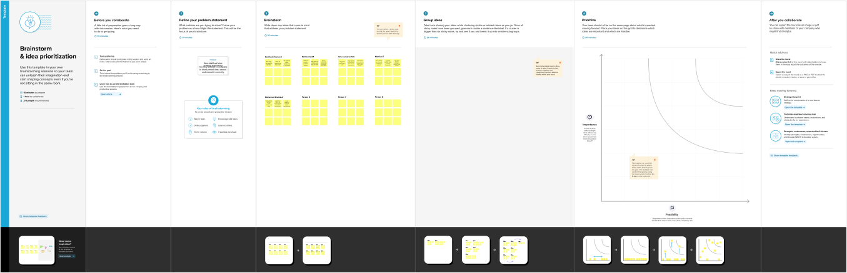

|  |  |  |
| --- | --- | --- |
| OBJECT | Fields in the Object | |
| Job Applicant | FIELD NAMES | DATA TYPES |
|  | Customer Name | Text |
|  | Job Type | Text |
|  | Job Name | Text |
|  | Job Includes | Text |
|  | Opportunity | Text |
|  | Customer Mobile Number | Number |
| Employee | FIELD | DATA TYPE |
|  | Employee Name | Text |
|  | Mobile Number | Number |
|  | Employee Skills | Text |

3. Activity & Screenshot

 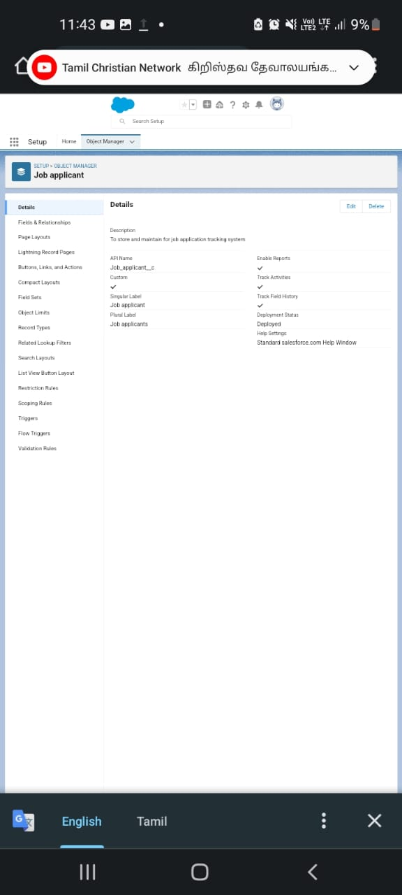

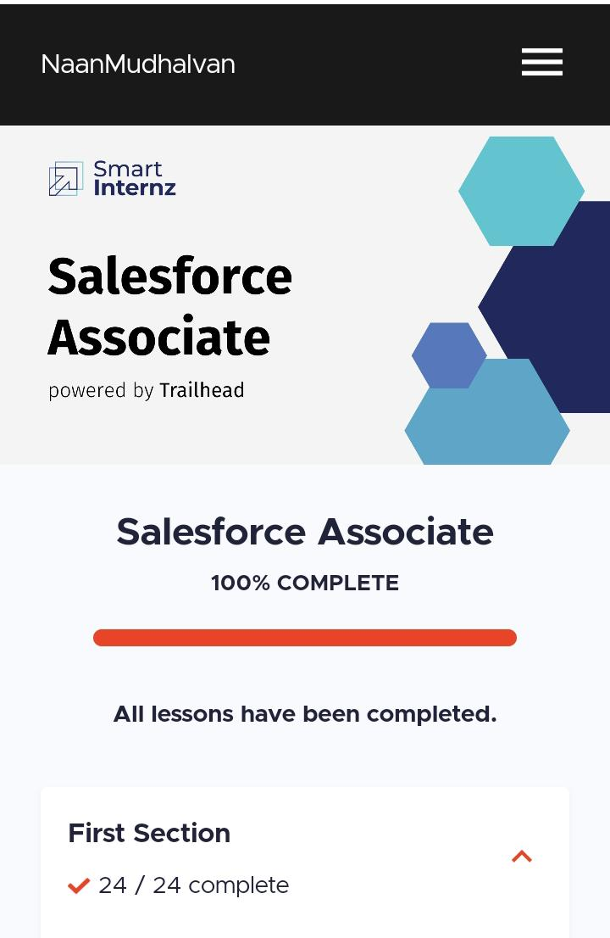

4.Trailhead profile public URL

TEAM LEADER : trailblazer.me/id/skumar9110

TEAM MEMBER 1 : trailblazer.me/id/ibnui

TEAM MEMBER 2 : trailblazer.me/id/ramkm7

TEAM MEMBER 3 : trailblazer.me/id/mahit67

TEAM MEMBER 4 : trailblazer.me/id/mohaa33

PROJECT REBORT TEMPLATE

5.Advantages :

(1) Reduces time spent on admin tasks…..

(2) Resume and CV screening……

(3) Speeds up the recturitment cycle…..

(4) Improves the quality of hire….

(5) Enhances reporting and compliance….

(6) Boosts your brand……

(7) Improves onboarding.

Disadvantages :

1. A Disadvantage of ATS is missing qualified applicants due to wrong keyword selection.
2. An applicant tracking system disadvantage is that they are open to manipulation.
3. Automatic elimination of resumes that software cannot recognize and interpret is another drawback of ATS.

6.Application :

(1) Align sales and marketing.

(2) Increase sales productivity.

Conclusion :

Applicant tracking system for recruiters is a very effective hiring solution that most of the successful recriters utilize.

8. Future Scope :

According to a recently released survey report, the majority of staffing firms worldwide will opt for an applicant tracking system by the end of 2020 to improve the overall talent acquisition efficacy, in this scope the future of ATS definitely looks bright.